## Taiwan Road test steps.

**Note**: these are not 100% but, after watching multiple videos and taking the test two times, I tried to document the details. I recommend you watch the videos. But keep in mind all testing facilities are not the same!

1. Silence phone; Keep **two hands on steering wheel**!
2. For whole test:
   1. Don’t cross white lines
   2. Don’t’ cross sensors (“pipes” as they call them)
   3. Always use turn indicator when turning – even if not needed. Will seem odd at times – like just turning right or left with no stop sign or stop light but they pretend it’s a “forked road”.
3. Before getting in the car,
   1. Check front, left tire pressure
   2. Check under front of car
   3. Check right front and right rear tires
   4. Check under back of car
   5. Check left rear tire
   6. Open car door 10 -15 cm with left hand then look right and left for traffic
   7. Then open and get in
4. Get in the car and:
   1. [Speak each action]
   2. Fasten seat belt
   3. Adjust seat (Left hand hold wheel, right hand adjusts seat)
   4. Adjust headrest with both hands
   5. Adjust rear view mirror with both hands
   6. Check right and left mirrors – **must rotate head**
   7. Press brake two times with right foot
   8. Right hand make sure gear shift is neutral (or Park)
   9. Set hand brake
   10. Check dash lights [and speak out each one]
       1. Switch ignition two clicks so lights come on
       2. Temperature, fuel, brake, battery, oil, engine
   11. Start car
       1. Set gear
          1. M: Press clutch and put in neutral
          2. A: Put in P and step on brake
       2. Turn on engine
       3. Release handbrake
       4. Turn head to check mirrors
       5. Turn on signal
       6. Go
   12. Back into parking spot (step 1 at Nanzi)
       1. Pull past the spot
       2. Look in both mirrors and rear
       3. Turn on blinker (right for Nanzi track)
       4. Back up slowly; watch **passenger mirror**
       5. When passenger door handle is at corner of curb (or, if there is a green pole on the right, when it is at the right side roof support), turn wheel hard to right and continue backward. Don’t worry if it looks like crossing the “pipe” a little due to wheel inset from car body.

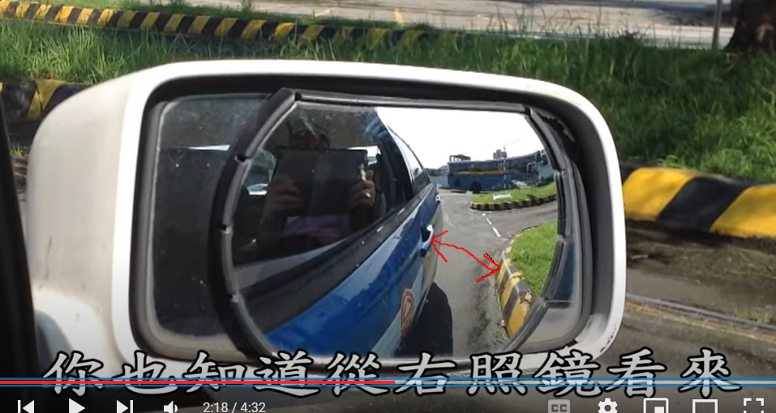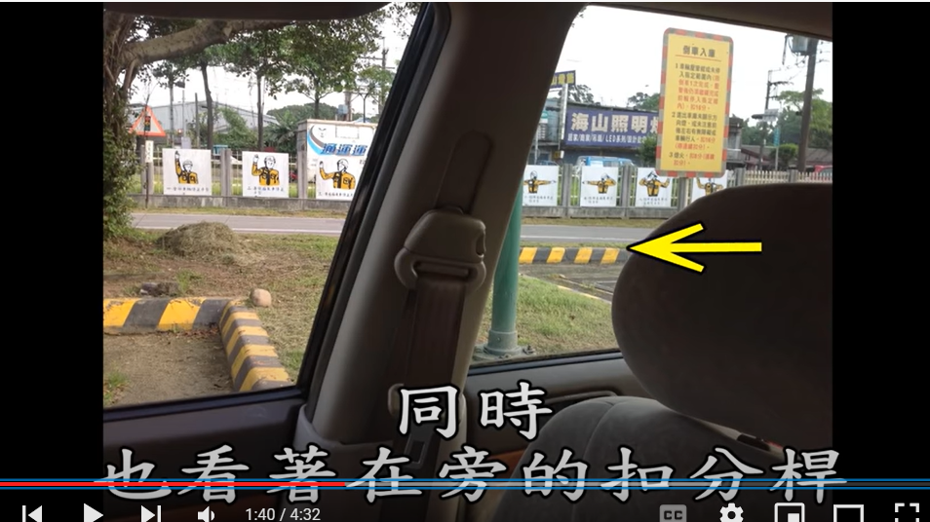

* + 1. Keep right door handle close to the sensor line (in the mirror)
    2. Check Left mirror to keep car in center; keep wheels turned until lined up with sensor lines then turn wheels straight
    3. Stop when front wheels clear white line
    4. [One try with no going forward / don’t’ stall engine]
    5. Set the parking brake. (Ask if you need to turn off the engine. Probably not. If the testing instructor didn’t when doing the dry run, then don’t need to.)
    6. When leaving, Turn on {left} blinker (Nanzi you turn left)
    7. Pull out straight until steering wheel is at pole then cut hard {left}
  1. Parallel parking
     1. Pull past the spot
     2. Look both mirrors, and front and back
     3. Turn on {right} blinker if backing up to right
     4. Back up slowly
     5. When passenger door handle is about at corner of curb, turn hard to the right

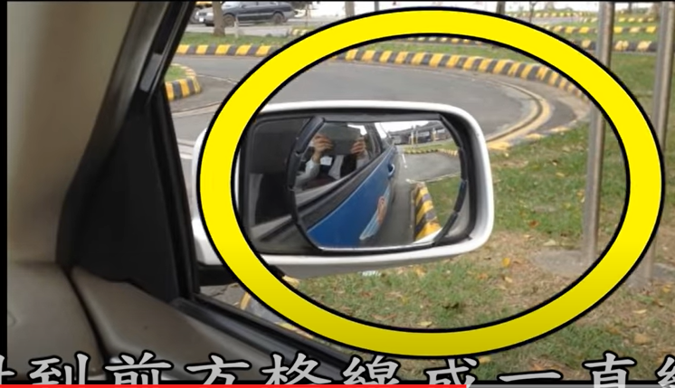(look at the mirror, not the s-curve in this picture)

* + 1. Keep wheels turned; switch to **driver’s mirror**; Look for triangle (see picture)
    2. Set front wheels straight
    3. Continue until driver door handle crosses white line (in the mirror)

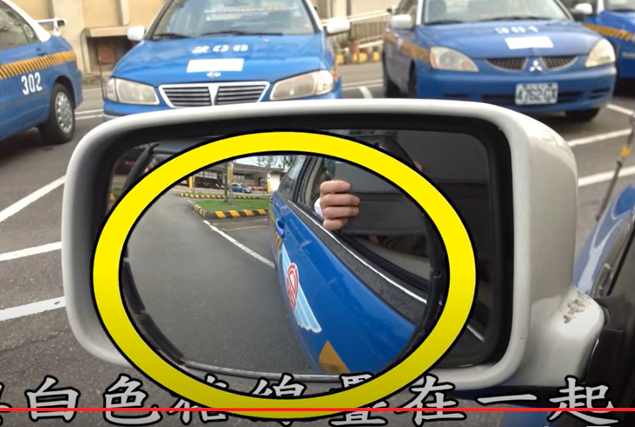(this is driver’s side mirror)

* + 1. Cut wheels hard to the left
    2. Continue backing up until front wheels clear white line
    3. [One try with no going forward / don’t’ stall engine]
    4. Set the parking brake. Ask if you need to turn off the engine. Probably not. If the testing instructor didn’t when doing the dry run, then don’t need to.
    5. When leaving, Turn on right blinker
    6. Turn wheels hard to left and pull out until ???
    7. Turn wheels hard to right
  1. Winding Road (S-turn)
     1. Forward:
        1. Turn on blinker
        2. Look both ways and check mirrors
        3. Pull straight until steering wheel is in line with first curb of the s-turn
        4. Hard right turn to pull into the s-turn
        5. Straighten out and proceed forward until time to turn left (when?)
        6. watch left mirror and continue turning left.
        7. Keep a close distance between driver door handle and sensor line - not too close
        8. at “top” of the curve, set front wheels straight and switch to right mirror
        9. Keep a close distance between passenger door handle and sensor line - not too close
        10. Continue turning right until exit the s-turn
        11. Set parking break?
     2. Reverse
        1. turn on Right blinker before starting to back up
        2. Look both ways in mirrors
        3. basically, watch mirrors as backing up so they don’t hit sensors (although it’s ok to cross over them when backing up, but don’t hit the curb)
        4. the rest of this needs to be validated with a youtube video
           1. Watch Right mirror and back up until passenger door handle at start of rounding of curb
           2. turn wheels to right; keep watching right mirror
           3. Keep a close distance between passenger door handle and sensor line - not too close; you’ll see the opposite curb in the distance
           4. when can’t see the distant curb, switch to Left mirror; keep wheels turned
           5. when see “top” of s-curve in left mirror, turn straight
           6. as left curb curves, turn left to follow.
           7. Keep a close distance between driver door handle and sensor line - not too close
           8. turn on right turn signal.
        5. Keep close to right entrance curb on way out if its a 90 turn entrance and cut wheel hard to the right after rear tires pass the curb corner
        6. [No deduction for touching lines]
        7. [Don’t go forward when backing up]
        8. [Don’t stall the car]
     3. AT END,
        1. Turn on blinker (Right)
        2. Look in mirrors and both ways for cars/pedestrians
        3. continue backing into the street
  2. Driving the circuit
     1. Use blinker
     2. Turn head and check mirrors (and rear)
  3. Gear change test
     1. Stop before line
     2. Don’t run over the line guides
     3. Shift up to 3rd gear w/in 45M
     4. Don’t stall
  4. RR Crossing
     1. Approach RR slowly – under 15 KM/H
     2. Stop before line if warning bell or sound
     3. Don’t stop on RR crossing or stall
     4. Check both ways before proceeding across RR tracks
  5. Up/Down Hill
     1. Don’t cross side guiding lines
     2. Drive line up on the second sensor from the left
     3. Don’t roll back
     4. Don’t stall
     5. Stop inside the area marked in yellow/black?
     6. Down hill
        1. Don’t shift to neutral or coast
  6. Crosswalk
     1. Stop before line
     2. Check with mirrors and turn head to look before proceeding
  7. End of test
     1. Apply parking brake
     2. Put in neutral (or Park on auto trans)
     3. Turn off engine
     4. Two-stage door opening
        1. Open door with RIGHT hand, just a few centimeters
        2. Look both ways for pedestrians
        3. Open door rest of way (but not all the way) to get out.

Kaohsiung Nanzi testing center order:

1. Reversing into “storage” (a parking spot)

2. Curve forward and backward (the famous “s-turn”)

3. Parallel roadside parking

4. Fork road

5. Up and down ramps (stay within the lines; don’t roll back on uphill from stop)

6. Shift Stability Test (for manual transmission)

7. Zebra crossing & railway level crossing

9. Ring Road

**Note**: This order may be different from other testing centers and was different from the Driver’s Training course I practiced at.